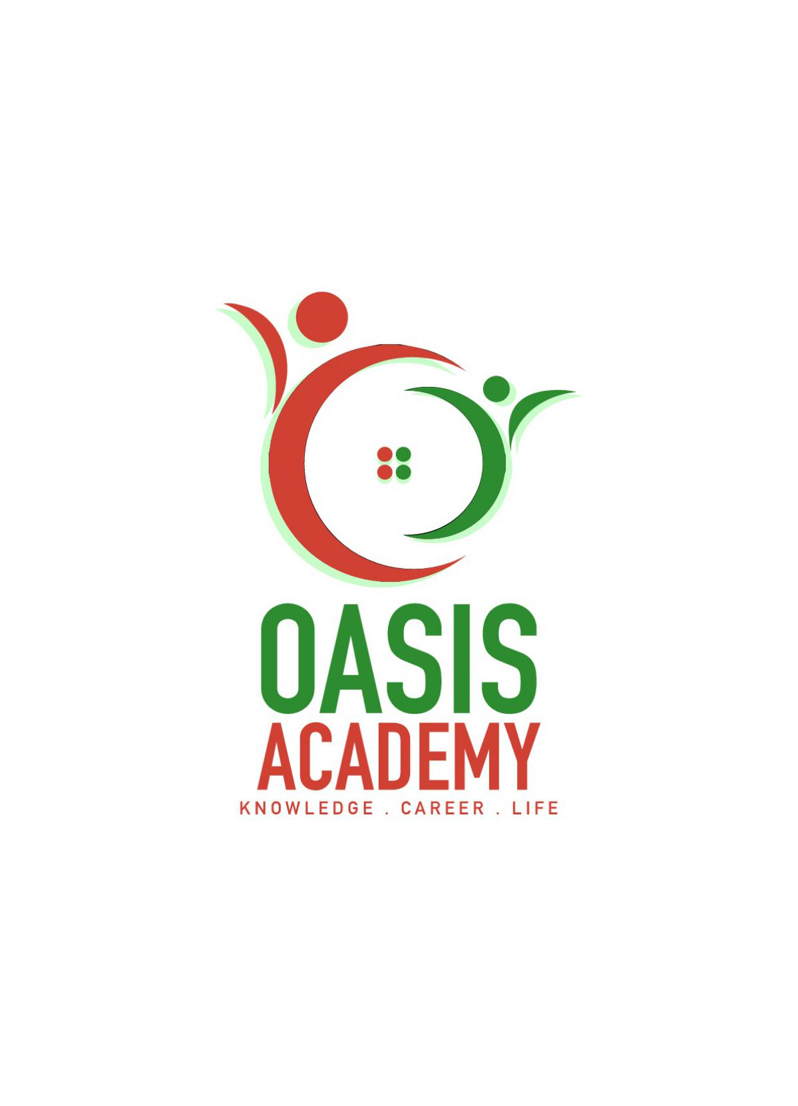

Name: Kiruthika Rajandran

Login ID: R03412919@oasis-portal.my

Course Title: Tourism & Hospitality

Subject Code: BHM 04

Submitted date: 11/9/2017

**Table of Contents**

|  |  |  |
| --- | --- | --- |
| **No** | **Details** | **Page** |
| 1 | Executive Summary | 2 |
| 2 | Introduction | 3 |
| 3 | Assignment Question |  |
|  | Part 1 | 4-7 |
|  | Part 2 | 8-10 |
|  | Part 3 | 11-15 |
|  | Part 4 | 15-20 |
| 4 | Conclusion | 20 |
| 5 | References | 21 |
|  | Appendix | 22-23 |

**Executive Summary**

In this assignment, I am going to discuss about tourism and hospitality. Based on my understanding, tourism is an activity that human travel from one place to other place. Hospitality means that the main place tourist stay overnight. Hospitality sector must have guest and host.

In this project, I will explained about the several question on tourism and hospitality. In first part of assignment question, I’m defined the tourism and hospitality and explain my understanding about hospitality industry. Secondly, I answered the second part with brief on different type of tourism categories and define tourism. Third part of the question was describe the lodging accommodation and type of hotel accommodation. The final part of the question was explain the significant of entertainment in hospitality management industry. Overall I have explain how does the hospitality industry works.

**Introduction**

Tourism is a vast subject which has with various branches. There are companies and sectors that benefit directly and indirectly from this large sector both in the long and short run, these sectors rely on the inflow of tourists or foreigners from other countries to keep their business moving. Moreover, apart from banking, sports and other industries which are rigid but also paramount to the effective running of other sectors of the economy, the decision to bring the entertainment part of the tourism industry is due to the important role it plays in the tourism industry. Little attention is paid to this aspect of the tourism industry but many tourists on holiday trips across the globe and away from their familiar region always depend on the entertainment sector of the tourism industry to give them a memorable and pleasurable holiday.

Hospitality industry one of the fastest growing sectors of the economy of the current time which is a multi-billion dollar enterprise. Hospitality Industry is exciting, always innovative and offers unlimited opportunities which is one of the first businesses in history. Individuals have always gone out for work or leisure purpose – to enjoy with family/friends. Hospitality sector is flourishing at an exceptional pace. The business basically consists of three capacities: management, kitchen and workers. All the three capacities when managed properly contribute in managing hospitality in an effectual way. This sector can also be divided into two parts: entertainment areas like clubs and bars, and lodging or accommodation.

Tourism and hospitality business in any country helps in creating more income for the locals. Tourists pay altered taxes to the government which helps the country to develop. Tourists also support the local traders to receive extra revenue and profits by shopping. The growth of tourism and hospitality business offers multiple opportunities to small operators and communities. This is why numerous developing as well as developed countries all around the world are encouraging this sector.

**Assignment Question**

**Question 1**

* *Define the Tourism and Hospitality*

**Tourism**

Tourism mean by travelling for recreational, leisure, family or business purposes, usually for a limited duration. Tourism is mainly associated with trans national level, but may also refer to travel to another location within the same country. It is important to preserve and protect our natural resources, culture and traditions and for this tourism is a vital factor.

Tourism is not only concerned with the movement of people but also includes various other service providing agencies. The movement of people is temporary in nature as it goes up to a maximum of 1 year but the impact on allied service industry is long lasting, which gives a boost to the economy, creating job opportunities.Tourism involves a break from the daily routine, offering peace of mind and cultural changes in the lifestyle.

The entire tourism process undergoes 3 phases starting from first phase which involves the movement of the person from his/her usual environment. Second phase is the destination and its access to the visitor, where he/she enjoys the tour. Third phase is concerned with returning from the tour/destination to the usual environment. Various factors like purpose of travel, holiday, health, culture, religion sports adventure, fairs and festivals, business etc have promoted it to an entertaining and joyful activity.

Tourism is not only on economic activity of great importance of national development but is also important medium of cultural exchanges among nations of world. A list of emphasis has been laid on the economic role of tourism. Its invoicing contribution in the foreign earnings of the nation and its potential for greater employment has earned it a reputation of being one of the fastest and steady growing sectors.

It is the right time today to understand the important role of tourism by means of social education and social mobilization in the country itself; as a competent force for forecasting better understanding among nations of world for developing closer cultural and business relation and as a significant factor contributing the world peace. The full impact of tourism on the national economy is not just through expenditure on the frontline tourist trade but also embraces all those industries which are outside the direct tourism sector are due to the deeds of the tourist who by spending their many facilities their need full existence.

**Hospitality**

The hospitality industry is a huge and famous industry in this world and there are multiple areas in this industry. This industry is specialized by training. This gigantic sector includes tourism and tour, traditional hospitality industry such as resorts and hotels, motel and a range of other hospitality services. Because of this industry is famous so there is several advantages and disadvantages in this industry.

The hospitality industry is famous for accommodation sector. They provide this sector with multiple categories. For example five star hotel, four star hotels, and three star hotels and so on. So those who are afford to pay the high fee they will choose their standard level hotel such as five star or four star hotels and those who are not afford to pay more fees only for the accommodations for a short period time will choose the lower level hotels. So its shows that this industry provide hotels for all the people according to their living standard.

* *Explain your understanding about Hospitality industry*

The hospitality industry includes several categories within service industry. These include lodging, cruise lines, transportation, restaurants and tourism industry. The hospitality industry is a multibillion investment in the world and its availability depends on the availability of disposable income and leisure time.

The hospitality industry is umbrella term for a broad variety of service industries, including, but not limited to, hotels, restaurant, casinos, catering enterprises, resorts, and clubs. The industry is very diverse and global, and is greatly impacted by fluctuations within the economy across the world. Hospitality industry is comprised of those businesses which practice the act of being hospitable; those businesses which are characterized by generosity and friendliness to guests.The term “hospitality” has become accepted over the years as a generic word, which describes the well being of services of facilities related to tourists and travellers.

The advantage of hospitality industry is that, they afford to provide the full service to their customers. For example, many hotels or resorts are around-the-clock, provide 24-hour operations and staffs are required to work varied shifts and extended hours for their customer satisfaction. Its means they provide the services for their clients all the time. Without bothering the time of the clients ask for the service. For example if any of the clients need foods or any other service at midnight means they can provide all the service to them without any further adore.

Besides that, this industry also provides other services such as tour and tourism beside provide only the accommodation service. Mostly the resort department will provide this as their service. It is because mostly the resorts will located at beach site waterfall site. So the people those who are go there can enjoy the beach site by staying there for 2 days or more than 2 days. In this situation, the industry helps their client to enjoy the nature by staying at beach site. The resorts also sometimes will build at jungle site. Those who is interest for stay in jungle for get any different experience they can go there and stay there and at the same time can enjoy the jungle life.

Then glamour myth also a advantage of the hospitality industry. Is means the hotel industry offers you the chance to meet rich, famous and interesting people. So we can meet them at the place where go for rest but at the same time it brings benefit to us. Can get meet any famous person or any important person who are in the same carrier with us. For example, if I'm a business person I can get to meet any other business person who is carry on the same business with me, so I can develop my business very well and famous. At the same time they can include scientists attending in-house conferences, foreign tourists, local business people, cinema stars and ordinary everyday citizens.

Furthermore the hospitality industry provides the standard living for their client. They provide services with the standard level such as the rooms that they provide the foods that they provide. They provide the rooms with full furniture and all the equipment. So the client will happily can enjoy all the service of them. So they will satisfy with their service and may be the loyal to the particular hospitality industry.

With the advantages of hotel Industry come the disadvantages too. The disadvantage of this industry is long and odd hours. This means that if the client or customer of that particular hotel doesn't like early starts or late finishes, then the hotel industry may not be help them. They may make late to help the client purposely.

Besides that, pressure, high standards and deadlines also a disadvantages of the hospitality industry. Working for demanding clients and management is not the downside of working in hotels - for it is what the industry is all about - but you may find that the pressure of guest and management expectations are more stressful than you ever imagined. Pressure and deadlines are intrinsic elements of the industry and the best hotel workers thrive on conquering the challenges and obstacles placed in the way of personal and company objectives.

Culture problem also consider as a disadvantage of this industry. Most of the hospitality industry provides their service with the western style but it not suitable for all the clients of them. For example we can take the Malay religion, they cannot eat all the food especially pork at all and they can eat only 'halal' food so they face some problems. Then also must prepare with at least a special hall for their praying. Because Malays must at the correct time and must carry on the prayer at the special venue which is called as 'surau' if there don't have mosque.

So some of the hotel or hospitality management sometimes never provides or forget to prepare all this things to them. Besides Malays, in our country the Indian are sometimes will carry on the vegetarian. So the hotels must prepare the vegetarian foods for them. But they never provide this sometimes. So the clients need to go out site of the hotel for find the foods for them. This shows that the hospitality industry never give important for their clients.

As the conclusion, the hospitality industry provides the good service for their client with their variety service. But still this industry needs to improve their service to archive the target of their industry. if they improve all this the customers will get happy and will enjoy with service.

**Question 2**

* *Brief on different type of Tourism categories.*

**Leisure Tourism**

Tourists may travel to experience a change in climate and place and learn something new, enjoy pleasant scenery, or to know more about the culture of a destination. Tourists, who seek break from the stress of day life, devote their holiday to rest and relaxation, refresh themselves. These tourists prefer to stay in some quiet and relaxed destination preferably at a hill resort or island resort. Nowadays tourists undertake various adventures sports activities for leisure and to refresh themselves after working hard. This tourism includes following forms based on the activities undertaken.

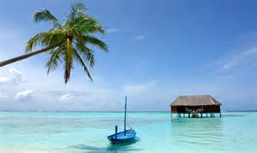

**Business Tourism**

The business traveler’s main motive for travel is work. Tourists visit a particular destination for various reasons pertaining to his /her work such as attending a business meeting, conferences, conventions selling products, meeting clients. Business tourism is popularly called as MICE (Meetings, incentives, conferences, and exhibitions) tourism.



**Educational tourism**

Educational tourism developed, because of the growing popularity of teaching and learning of knowledge and the enhancing of technical competency outside of the tour visiting another country to learn about the culture, such as in student Exchange Programs and Study Tours, organizing specialized lectures of the eminent personalities and for research

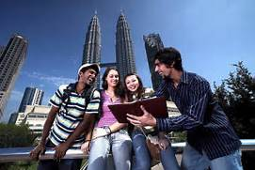.

**Family Tourism**

Family tourism involves the family unit and their participation in diverse forms of tourism activity. This includes visiting one’s relatives and friends for interpersonal reasons. Many people in India travel for visiting their friends and relatives. While visiting friends or relatives, people also visit tourists’ attractions in and around the city.



**Religious tourism**

It is also called as pilgrimage tourism / spiritual tourism, where people travel individually or in groups for pilgrimage. The world’s largest from of mass religious tourism takes place at the annual Haji pilgrimage in Mecca, Saudi Arabia. Modern religious tourits are more able to visit holy cities and holy sites around the world.

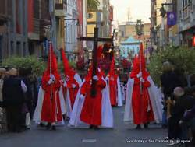

* *Define Tourism*

Tourism as an industry has been travelling with the wild pace of technological advancements and aboard are people from different places and cultures interacting with increasing ease and the globe had been shrunk into a village.

Unlike our predecessors, we can affordable and in a shorter time travel across the world in large numbers comparatively safe. Tourism being one of the biggest and fastest growing industries globally, its benefits and the challenges, keenly observed by governments affects the economic, socio-cultral, environmental and educational resources of nations.

The positive effects of tourism on a country’s economy include the growth and development of various industries directly linked with a healthy tourism industry, such as transportation, accommodation, wildlife, arts and entertainment. This brings about the creation of new jobs and revenue generated from foreign exchange, investments and payments of goods and services provided. Though improvements in the standard of living of locals in heavily visited tourist destinations is usually little or non-existent, inflation of the prices of basic commodities, due to visiting tourists,is a constant feature of these areas.

**Question 3**

* *Describe the lodging accommodation*

**Lodging Accommodation**

Lodging, also known as accommodation, is a place to sleep for one or more nights. Lodging is an inclusive term that defines the different types of accommodations available to a traveller. Lodgings may vary in each country but due to globalisation most lodgings today are standardized with international services. A business in the lodging industry is a business that provides a place for people to sleep overnight. It can be one of many sleeping places such as a fancy hotels, a youth hostels, elder hostels, a campgrounds, highway side motel. An extravagant resort, for instance, should offer its customers privacy and exclusive services to cut it in the niche.

Lodging businesses markets to other market segments such as business travelers, leisure travelers, long-stay travelers, budget travelers and special travelers like people working with the government, airlines, and military. This sector of the hospitality industry features a gamut from luxurious hotels to lavish resorts and campgrounds. Accommodation is an absolutely broad sector of the hospitality industry, ranging from bed & breakfast enterprises and hotels to other facilities that offer lodging services. Again, customer service is indispensable in providing accommodation services. And that isn’t all – efficiency, integrate comfort, and world-class amenities are also its foundation.

The lodging sector which serves both vacationers and business travelers and which made huge revenue. Lodging types include budget accommodations (e.g., EconoLodge, Super 8, and Motel 6), midpriced lodgings (e.g., Sheraton, Marriott), and high-end luxury hotels (e.g., W Hotels, Ritz-Carlton), as well as hostels, campgrounds, and bed-and-breakfasts. Major players in this sector include Carlson Companies, Cendant, Hilton, Marriott, Starwood Hotels & Resorts, Accor, and Choice Hotels.

* *Types of Hotel Accommodation*

**Business Hotels**

Business hotelsspecialize in providing business related facilities and amenities for the business and corporate traveller. The facilities will include business centers that provide meeting rooms, secretarial services and modern telecommunication facilities including the internet. The business centers are equipped with modern office automation. A business lounge allows executives to have private meals and will have the latest newspaper and perhaps a library. The rooms of business hotels will be equipped with high speed internet facilities, direct dial telecommunication link-up globally ergonomic writing desks and chairs, mini bar, safety lockers, multi-channel television etc. Services could include limousine service to and from the airport, concierge service, same day laundry service, health club, access to golf courses, etc.

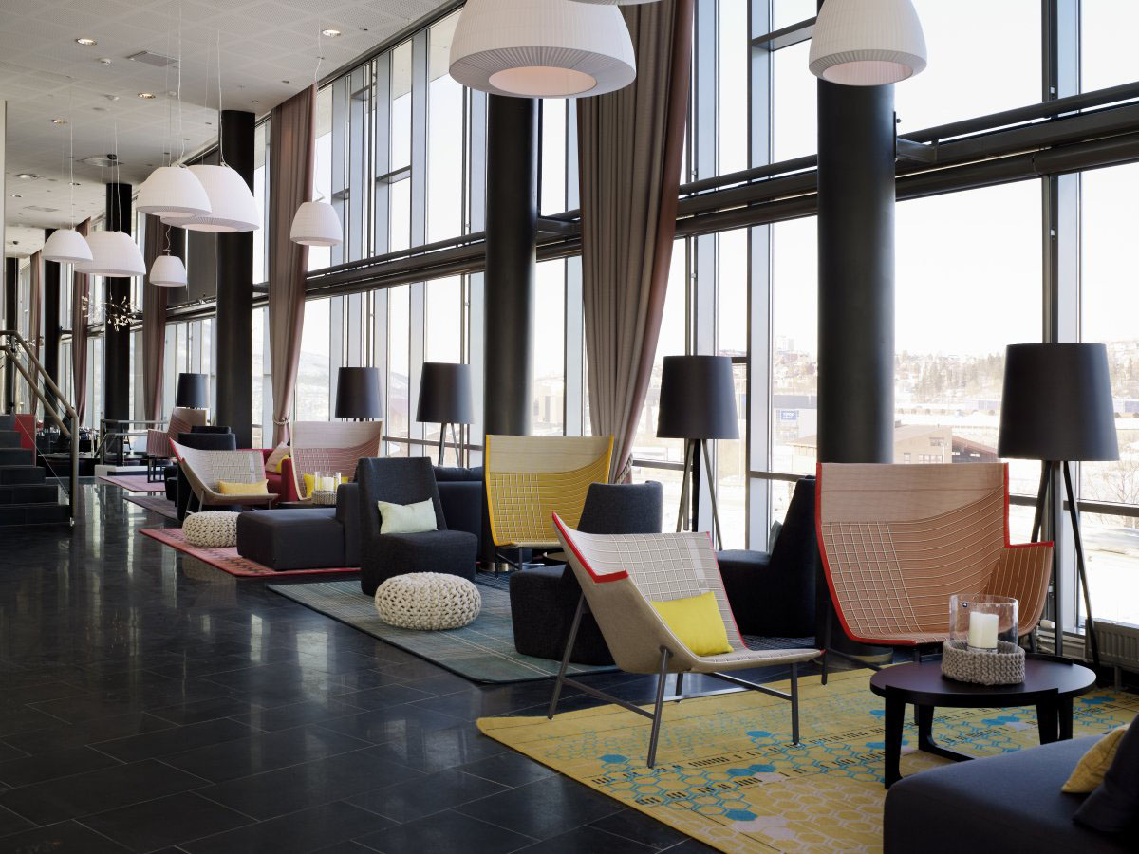

**Budgets Hotels**

Budgets hotels are relatively a new concept that make travel inexpensive in a world that is getting more and more costly. Budget hotels strip rooms and services to the bare minimum and use automation to fulfill many guest needs. A room would have bunker beds with perhaps a sink in the room for washing purposes. There would be common toilets. A mini-television will bee mounted on the wall to save space. Budget hotels will have dispensers for hot and cold foods, ice, alcoholic and non-alcoholic beverages, toiletries and etc. Located at common areas on the floors or lobbies. Many motels have built these facilities into their way of operations.

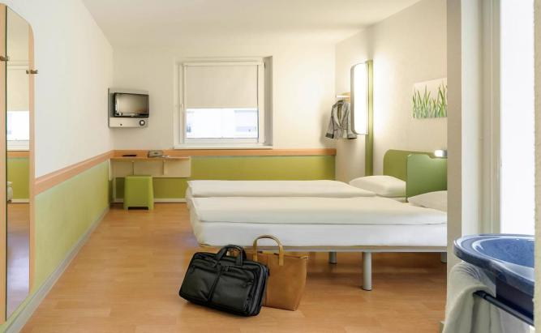

**Deluxe Hotels**

Deluxe hotels would normally have a minimum five-star rating. These hotels are rated as deluxe as they would have decor and appointments of luxury. They would have every conceivable comfort built into the guest experience. Take Burj-al-Arab in Dubai where accommodations are suites that overlook the Persian Gulf. The rooms are fitted with remote control window shades, gold plated taps, etc. Guests are transported to the hotel from the airport by the helicopter that lands on a helipad on the hotel rooftop. Deluxe hotels ooze opulence and are available only to those moneyed people who can afford the stay. Some deluxe business hotels provide individual butlers and specialized cuisines. Many older stand-alone hotels like Trumont House, The Claridges, etc set standards of luxury. Many palaces, mansions and villas of the royalty of yore converted their lodgings into hotel which really cannot be given a star rating for their uniqueness and may be certainly classified as deluxe.

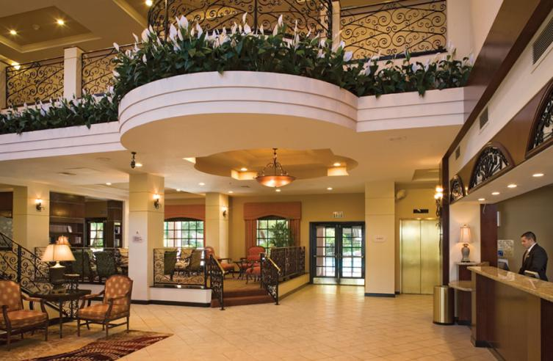

**Bed and Breakfast**

Bed and breakfast establishments are usually small family business. A family may have an extra set of rooms in their home that they let out to tourists. This is a typical concept from Europe which perhaps earlier did not have well-developed hotel facilities. Ireland and Scotland, for example, supplement hotel accommodation in the huge tourist season with bed and breakfast properties. The family of the establishment takes the responsibility of providing comfortable rooms much in the home style with their dining rooms serving as the breakfast venue. They serve sumptuous English Breakfast with a full array of cereals, meats, breads and tea and coffee. These breakfasts are famous among travellers who could sustain a full day till the evening with this meal.

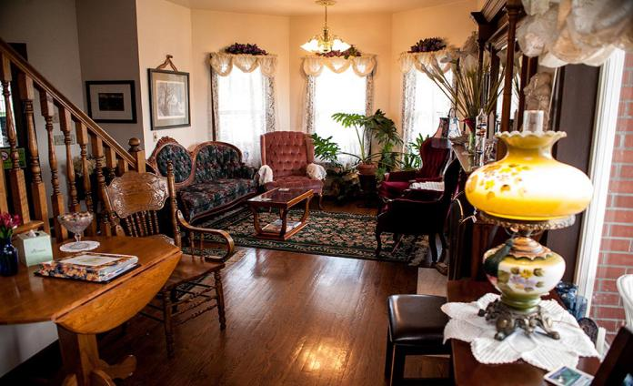

**Motels**

Motels are located on principle highways and road junctions. It is a lodging facility with 15-100 rooms for the automobile traveller. Motels have independent entrance to their rooms which guests have access to, after they have registered themselves at the reception. Motels are low buildings maybe a story or two at most. With ample parking spaces, guests can park their cars in front of their rooms. They do not have the tedium of unloading and reloading their transport with this facility. The rooms are equipped with tea/coffee kettles, tea/coffee satchels, creamers and sugar to make their own hot beverages. The room has also a microwave oven to heat their own food. The motel may or may not have a diner and a bar at the most. They supplement eating facilities with food and beverage dispensers at convenient spots on the floor. Earlier motels provided garage facilities for car servicing and handling breakdowns. This is not always possible these days. Rooms are simple and clean with hot and cold shower or bath facilities. Guests have an overnight stay at the most

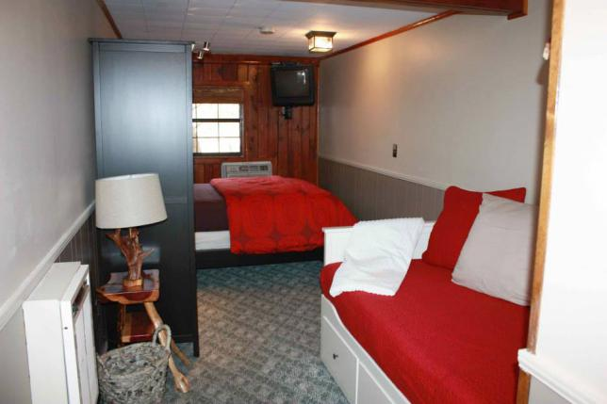.

**Question 4**

* ***Explain the significant of Entertainment in this industry***

Recreation and Entertainment is expected to be the fastest-growing tourism sector with annual employment growth. A key component of the tourism industry is attractions, which offer visitors a chance to explore the sights, facilities and wonders of their destination. Attractions generally include historic sites, heritage homes, museums, halls of fame, art galleries, botanical gardens, ski hills, aquariums, zoos, water parks, amusement parks, casinos and cultural attractions.

The Recreation and Entertainment industry includes myriad activities that range from bird watching and salmon fishing to horseback riding, whitewater rafting, golfing, wilderness trekking and educational visits to entertaining stops. Regardless of size, these venues need people to work in gift shops and restaurants, as well as help maintain the facilities, manage the operations and promote the attractions.

* ***Types of Entertainment in Hospitality***
* **Marinas**

The marina is to purchase a ramp to really get your boat in to the water as well. At larger marinas, there exists often everlasting dock space and winter safe-keeping available. These slips are especially convenient if you are a citizen or consistent visitor. Most marinas are privately held and funded, so they ask for usage of ramps, and will often have some kind membership payment to make use of the other marina service.

Learning to be a member has its advantages, such as discounted slide rental, usage of other service which could or might not exactly be accessible, depending on marina. Virtually all marinas offer some type of boat rental for many long island for your convenience.

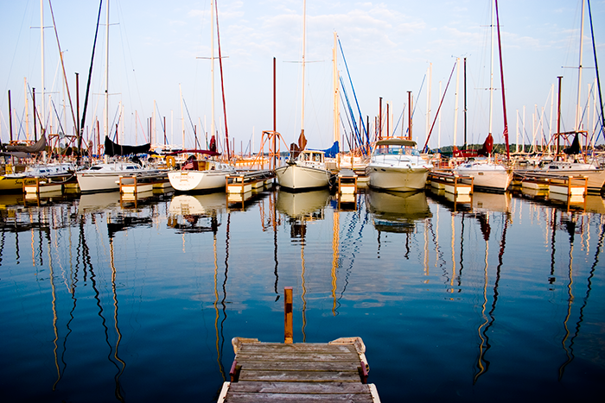

* **Sports and Gaming**

Sports entertainment refers to sports performed for the sake of entertaining an audience rather than for competition among participants. The best example of sports recreation is prowretling. The term was dubbed The world wrestling federations in the 80’s to describe their style of wrestling.

Sports complexes are essentially large theaters of entertainment, which ought to be pleasant to visit, like a cinema, and at the same time also be social and architectural and marks in towns and cities. A sports complex is a closely knit well-balanced grouping of indoor and out-door games facilities offering a wide range of activities on a comparatively small and area.

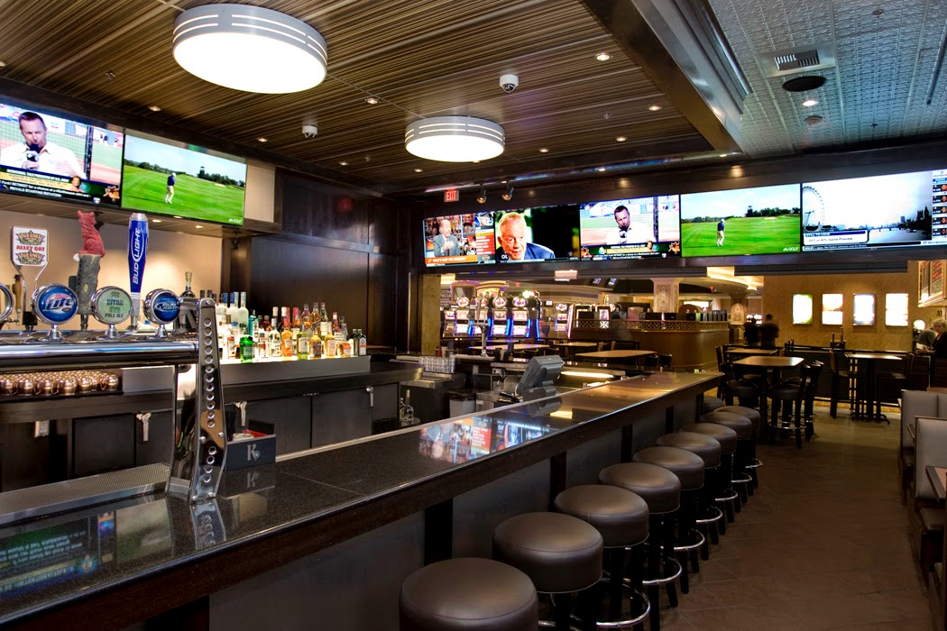

* **Cruise**

Cruise lines are included hospitality and tourism because while other modes of transportation, like airlines, are primarily about getting passengers from place to place, on a cruise ship the trip is the focus. Indeed, cruise ships are essentially floating resorts, with all the activities and amenities of resorts of every kind. The example includes Carnival, Royal Caribbean, Norwegian Cruise Lines, Royal Olympic, and Star Cruises.

Cruise  is a luxury vessel that is used to take passengers on a pleasure voyage in a journey that is as much a part of the experience as the various destinations on the way. In contrast to an ocean liner that transports passengers from one point on the globe to the other often across the oceans, a cruise ship or a cruise liner as it is known by most, takes the people on board to a round trip that is of varied duration, from a single day to possibly a week and culminates at the originating port. This is a very refreshing mode of enjoyment and recreation, which relaxes the mind and replenishes energies to a great extent.

The facilities on board these cruise liners include great dining services. Some liners offer open air dining on the deck, where as, there are others that have expensively designed dining halls with mouth watering recipes to leave a long lasting impression on the passengers. In addition to this there are casinos, fitness centers, spas, cinemas, and some ships even have a Broadway like theater. These cruise ships also boast of swimming pools, hot tubs, lounges, libraries, gyms and clubs. To put it in a nut shell, they pamper the passengers with the best of hospitality and services that can be imagined with some of the choicest natural views along the sea.

Over the last decade, cruising has become an integral part of the tourism industry contributing more revenue yearly to this booming sector. The major bulk of the business as expected comes from the North American and European regions but the other areas like the pan pacific are also catching up.

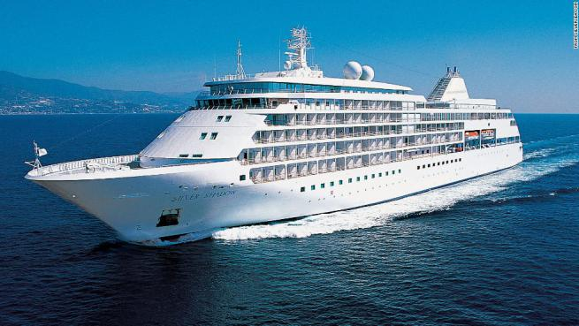

* **Bars**

Bars culture varies significantly from region to region. For example, while pubs are the most common drinking establishment in the UK, karaoke bars are popular in Japan, and techno dance clubs initially rose to prominence in Germany. Standalone bars are rare in some countries, including Italy, where alcoholic beverages are primarily sold in cafes along with coffee, meals, and snacks. Spain has the greatest number of bars per person in the world, according to Nielsen.

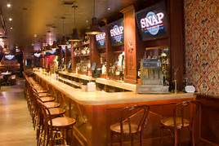

* **Nightclubs**

A nightclub is an entertainment venue and bar which serves alcoholic beverages that usually operates late into the night. A nightclub is generally distinguished from regular bars, pubs, or taverns by the inclusion of a stage for live music, one or more dance floor areas and a DJ booth, where a DJ plays recorded music and where coloured lights illuminate the dance area. Nightclubs are mush more likely than pubs or sports bars to use bouncers to screen prospective clubgoers for entry.

Nightclubs have highlighted some of the best party spots, bars and clubs around on both the south and west coasts. Some nightclubs bouncers do not admit people with ripped jeans or other informal clothing or gang apparel as part of a dress code. The busiest nights for a nightclub are Friday and Saturday night. Most clubs or club nights cater to certain music genres, such as house music or hip hop.

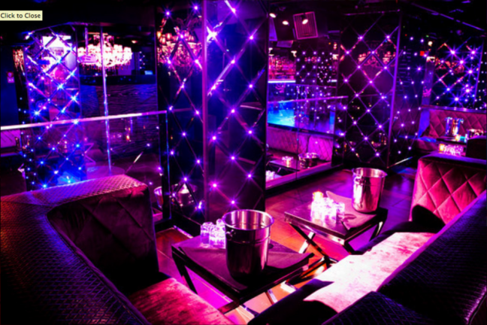

* **Travel Agencies and Travel Packages**

Travel agents and packagers help travelers plan their business trips and vacations. Travel agents help business travelers and tourists plan and purchase everything from airline tickets and car rentals to resort stays and attraction tickets. Travel packagers put together trips for individual tourists or groups of tourists, arranging for everything from hotel stays and restaurant reservations to tours guides, theater reservations, and sports lessons. Smaller travel agencies and packagers are more likely to focus on a single market, activity, or location. For example, one travel packager might focus on singles tours, another might offer only surf tours, and another may concentrate on tours of Asia. Major players in this category include American Express, Cendant, Expedia, Orbitz, Travelocity, Carlson Wagonlit Travel, WorldTravel, Maritz Inc., and World Travel Specialists Group.

**Conclusion**

Tourism is not only on economic activity of great importance of national development but is also important medium of cultural exchanges among nations of world. A list of emphasis has been laid on the economic role of tourism. Its invoicing contribution in the foreign earnings of the nation and its potential for greater employment has earned it a reputation of being one of the fastest and steady growing sectors.

The hospitality industry is a huge and famous industry in this world and there are multiple areas in this industry. This industry is specialized by training. This gigantic sector includes tourism and tour, traditional hospitality industry such as resorts and hotels, motel and a range of other hospitality services. Because of this industry is famous so there is several advantages and disadvantages in this industry.

In this part, tourism and hospitality business enhance by the speed of technological development. An effectively implementation of technology is a key factors in ensuring the growth of tourism and hospitality business and the a continuing value for future use. Hospitality and Tourism industry Careers are challenging and provide many opportunities to be creative to exceed guest expectations.

Tourism and hospitality business in any country helps in creating more income for the locals. Tourists pay altered taxes to the government which helps the country to develop. Tourists also support the local traders to receive extra revenue and profits by shopping. The growth of tourism and hospitality business offers multiple opportunities to small operators and communities. This is why numerous developing as well as developed countries all around the world are encouraging this sector.

**References**

1. <https://www.ukessays.com/essays/tourism/individual-assignment-the-introduction-to-hospitality-tourism-essay.php>
2. <https://www.coursehero.com/file/11156460/Assignment-2-Overview-of-the-Hospitality-and-Tourism-Industry/>
3. <https://www.bookmyessay.com/tourism-and-hospitality-assignment/>
4. <https://www.assignmentpoint.com/arts/sociology/definition-tourism.html>
5. <https://books.google.com.my/books?id=PrRdc5SI_R4C&printsec=frontcover#v=onepage&q&f=true>
6. <https://books.google.com.my/books?id=kkJro7zYe2YC&printsec=frontcover&dq=lodging+and+accommodation+in+hospitality+industry&hl=en&sa=X&redir_esc=y#v=onepage&q=lodging%20and%20accommodation%20in%20hospitality%20industry&f=false>
7. <http://essay-samples.blogspot.my/2011/11/hospitality-industry-essay_27.html>
8. <https://studymoose.com/hospitality-industry-essay>

**Appendix**

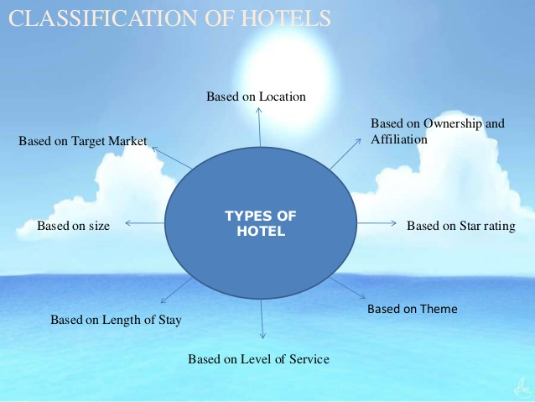

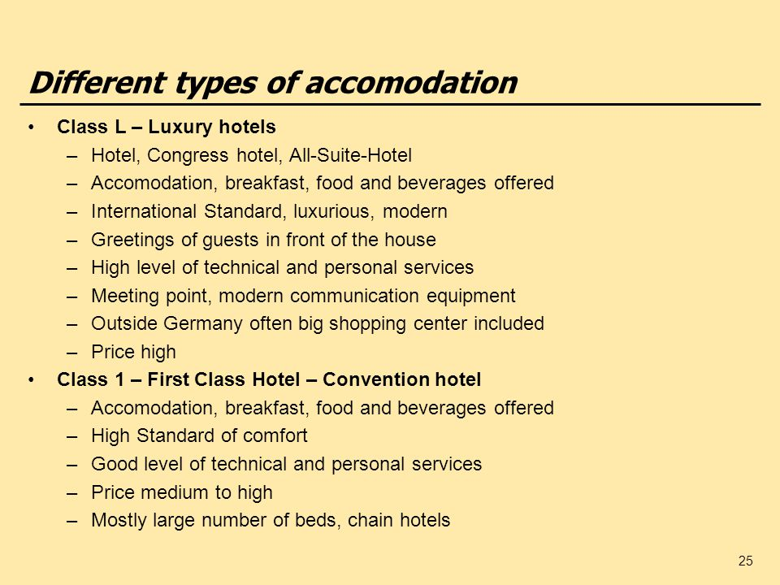

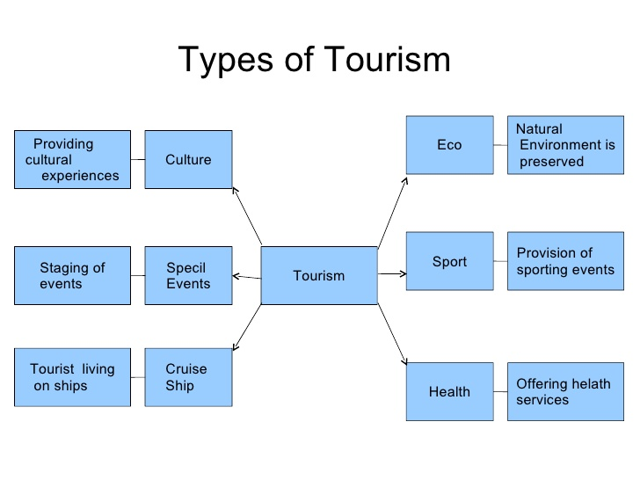

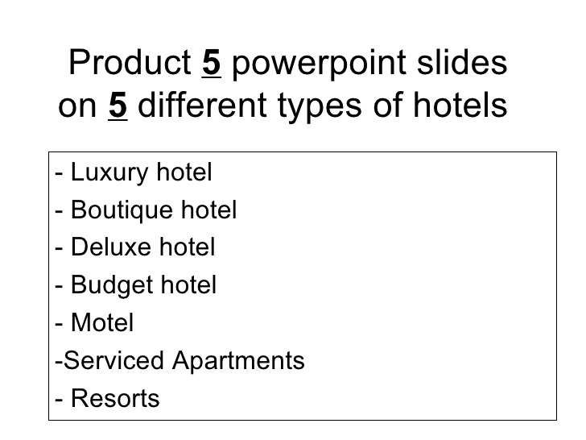

THE END